**Lab 3: Views: Execute DDL statements which demonstrate the use of views. Try to update the base table using its corresponding view. Perform view creation from multiple tables.**

Views in SQL are kind of virtual tables. A view also has rows and columns as they are in a real table in the database. We can create a view by selecting fields from one or more tables present in the database. A View can either have all the rows of a table or specific rows based on certain condition.

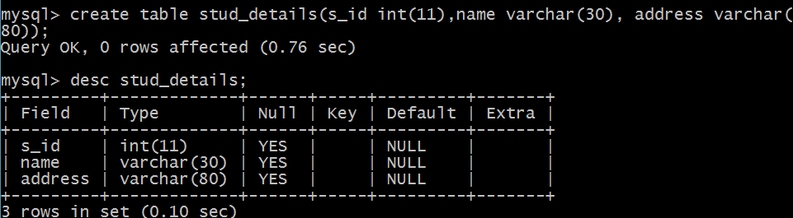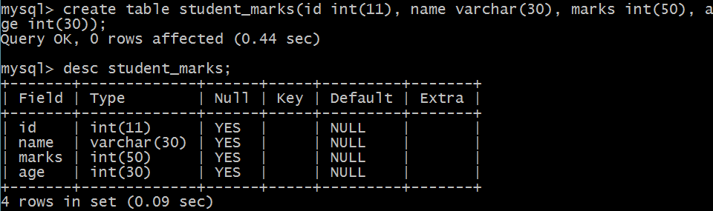

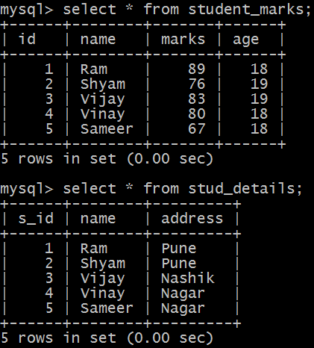

**Creating simple view from single table**

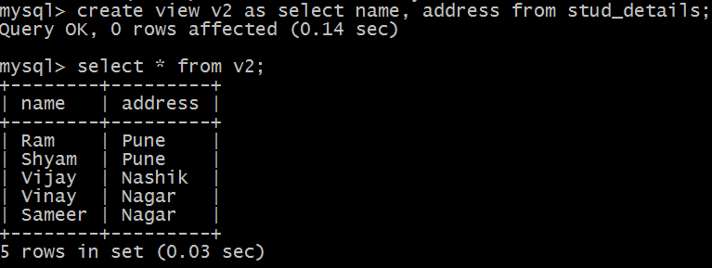

**Creating simple view with order by clause**

**The SQL ORDER BY clause is used to sort the data in ascending or descending order, based on one or more columns.**

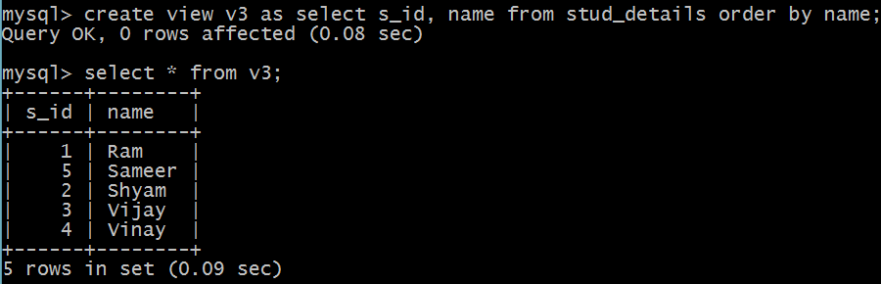

**Create view from multiple tables**

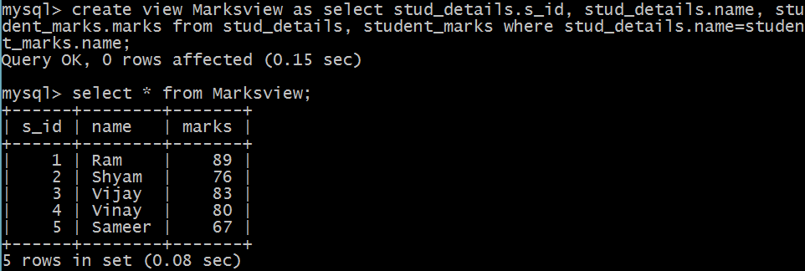

**MIN and Max function in sql**

The MIN() function returns the smallest value of the selected column.

The MAX() function returns the largest value of the selected column.

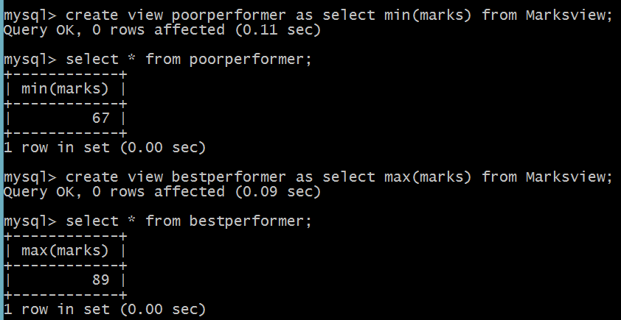

**DELETING VIEWS**

**Syntax**:

DROP VIEW view_name;

**Where view_name**: Name of the View which we want to delete.

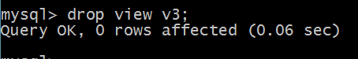

**UPDATING VIEWS**

We can use the **CREATE OR REPLACE VIEW** statement to add or remove fields from a view.  
**Syntax**:

CREATE OR REPLACE VIEW view_name AS

SELECT column1,coulmn2,..

FROM table_name

WHERE condition;

For example, if we want to update the view **MarksView** and add the field AGE to this View from **StudentMarks**Table, we can do this as:

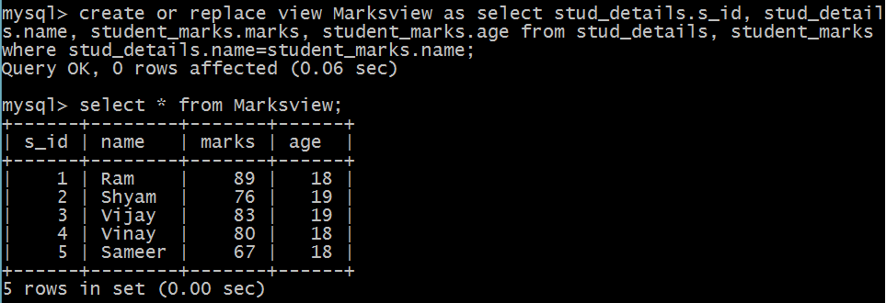

**Inserting into simple view**

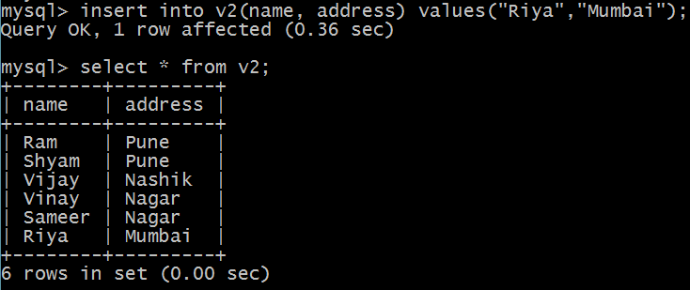

**Deleting a row from a View**:  
Deleting rows from a view is also as simple as deleting rows from a table. We can use the DELETE statement of SQL to delete rows from a view. Also deleting a row from a view first delete the row from the actual table and the change is then reflected in the view.**Syntax**:

DELETE FROM view_name

WHERE condition;

**view_name**:Name of view from where we want to delete rows

**condition**: Condition to select rows

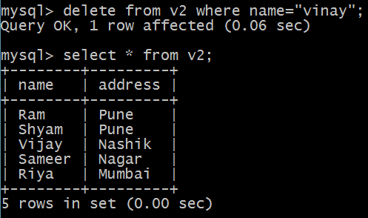

**Uses of a View :**  
A good database should contain views due to the given reasons:

1. **Hiding data complexity –**  
   A view can hide the complexity that exists in a multiple table join.
2. **Simplify commands for the user –**  
   Views allows the user to select information from multiple tables without requiring the users to actually know how to perform a join.
3. **Store complex queries –**  
   Views can be used to store complex queries.
4. **Rename Columns –**  
   Views can also be used to rename the columns without affecting the base tables provided the number of columns in view must match the number of columns specified in select statement. Thus, renaming helps to hide the names of the columns of the base tables.
5. **Multiple view facility –**  
   Different views can be created on the same table for different users.